“What would Seth Godin do?” module for Joomla!
User's Guide
Table of Contents
Introduction 1
Installation 1
Configuration 1
Module Details 2
Module parameters (basic) 2
Advanced parameters 3
Creating new templates 3
License 4
Copyright Notice 4

Introduction
The purpose of this module is to implement Seth Godin's idea to treat new visitors differently than returning ones, based on a cookie, as appeared in his “...in the middle, Starting” blog post. It's a good idea, as it can increase the number of people who subscribe to your RSS feed, newsletter and generally help people come back to your site.
The idea is implemented in a rather simple manner: new visitors are presented with a message of your liking. After they have visited your site for a few times (you can set how much is that) the message disappears. The counting is done using cookies set on your visitors' browsers.

Installation
You can install this just like any regular Joomla! module. Log in to your site's administrator section, click on the Extensions → Install / Uninstall menu item. Click on the Browse... button, select the module package (ZIP) file and click on the Upload File & Install button.

Configuration
The module configuration can be performed with the standard Joomla! manner, that is by using the Extensions → Module Manager menu and directly editing the “What would Seth Godin do?” module instance(s).

Module Details
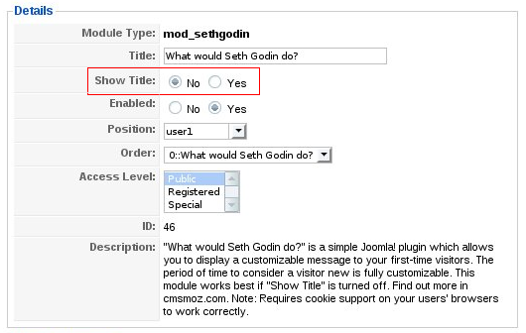Picture 1: Module details
On the left hand side of the module editor page, you will find the standard Joomla! “Details” section. It is very important to prevent displaying the title, by setting the Show Title option to No. Otherwise, returning visitors will see the module's title, but no module content. This will be confusing for them!

Module parameters (basic)
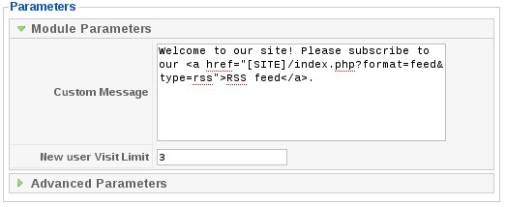Picture 2: Module parameters
The basic parameters can be found on the right hind of the module editor, under the “Module Parameters” pane heading. They are:
- Custom message. This is the message you want to show to your new visitors. You can freely enter any HTML you'd like, even Javascript, embedded video etc. There is one macro, [SITE], which will be substituted by your site's URL before the message is displayed. You can understand how it is used by observing the sample message in the picture above.
- New user Visit Limit. This is after how many visits your visitors will stop seeing the message. The default value, 3, means that during the first three visits the message will be displayed, but on the fourth and later visits from the same browser the message will disappear.
A note on visit limit counting: Multiple visits performed in the same calendar date (according to your site's server clock) and within the same session do not count towards this limit. For example, if someone visits your site 5 times in, let's say Monday, 2 times in Wednesday and 4 times in Thursday, he will only be counted as having performed 3 visits, not 11 visits. This is on the grounds that most people might find you from a search engine, visit your site, accidentally wander off your page and re-visit using the search engine's link. As they haven't really had the chance to familiarize themselves with your site, counting this behavior as two visits would make your message disappear too soon to be effective.
Also note that the cookie set on your visitors' browsers is set to expire in three months. This means that if someone hasn't visited your site for at least three months (90 days), he will be considered a new user and shown the message.
Configuration of the behavior described above will be the subject of a later version of the module.

Advanced parameters
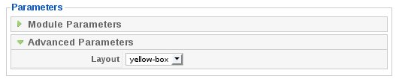
The advanced parameters can be found on the right hind of the module editor, under the “Module Parameters” pane heading. There is currently only one option, Layout. This determines the typesetting of the message, in case you're not that much into HTML. The available layouts are:
- alert-span. Wraps your message inside a <span class="alert"> tag. This notation is used in most RocketTheme templates to display a message inside an eye-catching red box. It will probably make no difference if you use a template from another source.
- default. Displays just what you've typed, without any extra typesetting, wrapped inside a <div> element.
- yellow-box. Wraps your message inside a padded box with yellow background and a thin red border.

Creating new templates
This is useful if you want to further customize your message. You can put any combination of PHP, HTML, CSS, Javascript, etc in a template, giving you infinite possibilities. For example, you may display a video, play an audio message, show an image or – why not? – start a Javascript-powered animated demonstration of your site's navigation features. It's raw power to your hands – if you're a developer.
Templates are stored in the modules/mod_sethgodin/tmpl directory. Each template is a PHP file. The minimal structure is:
- <?php defined('_JEXEC') or die('Restricted access');?>
- <div>
- <?=$message?>
- </div>
The first line is mandatory to avoid accidental exploitation by malicious people (crackers). The rest of the lines can contain anything you could put in a web page. If you want to display the customized message, make sure you put the <?=$message;?> tag where you want the message text to appear.
After you have created and saved your template inside the aforementioned directory, it will be selectable in the Advanced Options section.

License

This module is distributed under the terms of the GNU General Public License, version 3 of the license or – at your option – any later version. The full text of the license is available on-line at http://www.gnu.org/licenses/gpl.html.

Copyright Notice
“What would Seth Godin do?” module for Joomla!, version 1.0
Copyright © 2009 Nicholas K. Dionysopoulos / cmsmoz.com
This program is free software: you can redistribute it and/or modify it under the terms of the GNU General Public License as published by the Free Software Foundation, either version 3 of the License, or (at your option) any later version.
This program is distributed in the hope that it will be useful, but WITHOUT ANY WARRANTY; without even the implied warranty of MERCHANTABILITY or FITNESS FOR A PARTICULAR PURPOSE. See the GNU General Public License for more details.
You should have received a copy of the GNU General Public License along with this program. If not, see http://www.gnu.org/licenses/.

Strictly speaking, Joomla! starts a session upon visiting the site for the first time. The expiration time of the session is set in the Global Configuration. If the session expires between subsequent visits within the same day, these visits will count towards the New user Visit Limit.

